 |  | 2003  FORM VI  TRIAL HSC EXAMINATION

Chemistry
General Instructions  - Working time – 3 hours  - Board-approved calculators may be used  - Write using blue or black pen  - Draw diagrams using pencil  - A Data Sheet and Periodic Table are provided at the back of this paper  - Write your student number at the top of each page in Part B | Total marks - 100  Section I Pages 2 - 24  75 marks  This section has two parts, Part A and Part B  Part A - 15 marks  - Attempt Questions 1 - 15  - Allow about 30 minutes for this part  Part B - 60 marks  - Attempt Questions 16 - 28  - Allow about 1 hour and 45 minutes for this part  Section II Pages 25 - 29  25 marks  - Attempt ONE Question from Questions 29 - 32  - Allow about 45 minutes for this Section

Part A
Total marks (15)
Attempt Questions 1 - 15
Allow about 30 minutes for this Part

Use the multiple-choice Answer Sheet.
Select the alternative A, B, C or D that best answers the question. Fill the response oval completely.

Sample 2 + 4 =
(A) 2
(B) 6
(C) 8
(D) 9

If you think you have made a mistake, put a cross through the incorrect answer and fill in the new answer.

If you change your mind and have crossed out what you consider to be the correct answer, then indicate this by writing the word correct and drawing an arrow as follows.

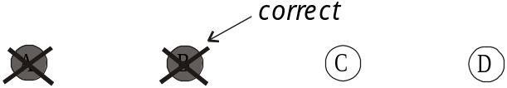

1 Which of the following instruments is used to detect radioactivity?

- Reflux apparatus
- UV – visible spectrometer
- Microscopic membrane filter
- Geiger counter

2 Plastic film for wrapping sandwiches is made from which of the following polymers?

- Low density polyethylene
- High density polyethylene
- Polystyrene
- Poly(vinyl chloride)

3 How can atomic absorption spectroscopy be used in the detection of pollutants?

- To find organic contaminants in a water supply.
- To analyse concentrations of non-metals in solution.
- To find the pH of a water supply.
- To analyse concentrations of metals in solution.

4 Which of the following indicators would be best for the titration of a weak acid with a strong base?

- Litmus
- Phenolphthalein
- Methyl orange
- Bromothymol blue

5 Which of the following is an industrial source of ethylene?

- The cracking of alkanes.
- The cracking of alkanols.
- The cracking of styrene.
- The cracking of polyethylene.

6 Which of the following chemical tests could distinguish between 1-hexene and hexane?

- Addition of CO₃²⁻(aq)
- Addition of SO₄²⁻(aq)
- Addition of Br₂(aq)
- Addition of Ag⁺(aq)

7 Which of the following types of radioactive decay produces an element with a larger atomic number?

- α and β decay
- gammma ray emission
- α decay only
- β decay only

8 Which of the following methods could you use in the laboratory to find the percentage of aspirin (acetylsalicylic acid) in a tablet?

- distillation
- titration
- gravimetric analysis
- evaporation

9 In which species does manganese have an oxidation number of VII?

- MnO₄⁻
- MnO₂
- Mn(OH)₂
- MnO(OH)₃

10 In a 0.25 M solution of H₂SO₄ the pH would be closest to which of the following?

- 0.8
- 0.3
- 2.5
- 1.0

11 Which of the following statements is true of a saturated solution of sodium carbonate?

- Addition of HCl(aq) would produce a precipitate.
- Addition of NaCl(aq) would produce a precipitate.
- Addition of CaCl₂(aq) would not produce a precipitate.
- Addition of HCl(aq) would produce a gas.

12 The formulas of four compounds are given below.

CHCl₂CHFCH₃ | CH₃(CH₂)₄CH₃ | CCl₃CClF₂ | CClF₂CCl₂F
W | X | Y | Z

Which of these compounds are CFC’s?

- W and X
- X and Y
- Y and Z
- W and Z

13 Which one of the following equations shows water acting as an amphiprotic species?

- H₂O(l) + H⁺(aq) → H₃O⁺(aq)
- 2H₂O(l) → H₃O⁺(aq) + OH⁻(aq)
- H₂O(l) → H₃O⁺(aq) + OH⁻(aq)
- 2H₂O(l) → H⁺(aq) + OH⁻(aq)

14 Which of the following chemists based his ideas of acids and bases on the fact that HCl and HCN for example were found not to contain oxygen?

- Davy
- Arrhenius
- Lavoisier
- Lowry

15 Which of the following statements is true of an equilibrium system?

- Changes to the system are minimised by a shift in the equilibrium position.
- There is constant change so properties such as colour or concentration continuously change.
- Changes to the system are completely reversed by a shift in the equilibrium position.
- There is constant change so rates of the forward and reverse reactions are never equal.

BLANK PAGE
Part B
Total marks (60)
Attempt Questions 16 - 28
Allow about 1 hour and 45 minutes for this Part

Answer the questions in the spaces provided
Show all relevant working in questions involving calculations

 | Marks
Question 16 (2 marks)
Isotopes may be stable or unstable depending upon the number of protons present, and the neutron to proton ratio.  Use equations to illustrate two modes of radioactive decay. | 2
……………………………………………………………………………….…………

……………………………………………………………………………….…………

 |  | Marks
Question 17 (2 marks)
The carbon compound C₅H₁₁Cl can exist as eight isomers. Draw and give the systematic name of two of these isomers. |  | 2

 | Marks
Question 18 (3 marks)
Account for the many uses of ethanol as a solvent. | 3
…………………………………..……………………………………………………...
…………………………………..……………………………………………………...
…………………………………..……………………………………………………...
…………………………………..……………………………………………………...
…………………………………..……………………………………………………...
…………………………………..……………………………………………………...

 |  | Marks
Question 19 (3 marks)
A water sample from a local creek was analysed and the following data collected.

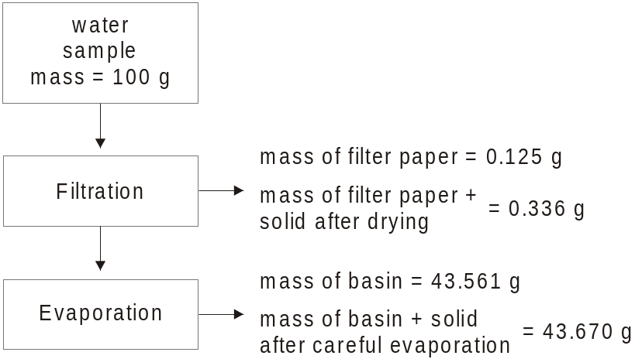
 | Find the percentage (w/w) of undissolved and dissolved solids in the above sample. | 2
………………………………………………………………………………...
……………………………………………….………………………………..
………………………………………………………………………………...
……………………………………………….………………………………..
 | Describe a test that could be carried out on the water sample to find the level of dissolved oxygen. | 1
………………………………………………………………………………...
……………………………………………….………………………………..

 |  | Marks
Question 20 (4 marks)
 | Write the equation for the formation of ammonia in the Haber process. Indicate whether the reaction is exothermic or endothermic. | 1
 | ………………………………………………………………………………...
 | The following conditions may be used in the Haber process:  - high pressure (35 MPa)  - intermediate temperature (525°C)  - a catalyst of Fe / Fe₃O₄  Explain the choice of the three conditions described above in the manufacture of ammonia. | 3
………………………………………………………………………………...
……………………………………………….………………………………..
………………………………………………………………………………...
……………………………………………….………………………………..
………………………………………………………………………………...
……………………………………………….………………………………..

BLANK PAGE

 |  | Marks
Question 21 (5 marks)
When a piece of zinc is added to an aqueous solution of copper(II) nitrate, the blue colour of the solution fades, the zinc disappears, and a brown solid forms.
 | Explain these observations in terms of oxidation and reduction, using half equations to illustrate your answer. | 3
………………………………………………………………………………...
……………………………………………….………………………………..
………………………………………………………………………………...
……………………………………………….………………………………..
………………………………………………………………………………...
 | Calculate the voltage produced if a galvanic cell was produced using zinc, copper and an appropriate electrolyte solution. | 2
………………………………………………………………………………...
……………………………………………….………………………………..
………………………………………………………………………………...
……………………………………………….………………………………..

 | Marks
Question 22 (5 marks)
Compare addition polymerisation and condensation polymerisation, using a specific example of each to illustrate your answer. | 5
……………………………………………………………………………….…………
……………………………………………………………………………….…………
……………………………………………………………………………….…………
……………………………………………………………………………….…………
……………………………………………………………………………….…………
……………………………………………………………………………….…………
……………………………………………………………………………….…………
……………………………………………………………………………….…………
……………………………………………………………………………….…………
……………………………………………………………………………….…………

 |  | Marks
Question 23 (5 marks)
Human activity impacts on waterways. Discuss this statement with reference to nitrate and phosphate levels in natural bodies of water. |  | 5
…………………………………………….…………………………………………...
…………………………………………….…………………………………………...
…………………………………………….…………………………………………...
…………………………………………….…………………………………………...
…………………………………………….…………………………………………...
…………………………………………….…………………………………………...
…………………………………………….…………………………………………...
…………………………………………….…………………………………………...
…………………………………………….…………………………………………...
…………………………………………….…………………………………………...

BLANK PAGE

 |  | Marks
Question 24 (5 marks)
Consider a cold, unopened bottle of soft drink, which has just been removed from the refrigerator. Explain the changes in the amount of dissolved carbon dioxide when the bottle is opened and as it warms up. |  | 5
………………………………………………………………………………..………...
………………………………………………………………………………..………...
………………………………………………………………………………..………...
………………………………………………………………………………..………...
………………………………………………………………………………..………...
………………………………………………………………………………..………...
………………………………………………………………………………..………...
………………………………………………………………………………..………...
………………………………………………………………………………..………...
………………………………………………………………………………..………...
………………………………………………………………………………..………...

Marks
Question 25 (9 marks)
The compound A (C₂H₄O₂) reacts with 10% sodium carbonate solution liberating a gas that turns lime water milky.

When A is heated under reflux with another organic compound B in the presence of a little concentrated sulphuric acid, a new substance D (C₄H₈O₂) can be obtained.

When the reaction is finished, the cooled reaction mixture is poured into a beaker containing an excess of 10% aqueous sodium carbonate solution. Two layers form. The organic layer is separated from the aqueous layer and then distilled to yield pure D.

The process is outlined below:

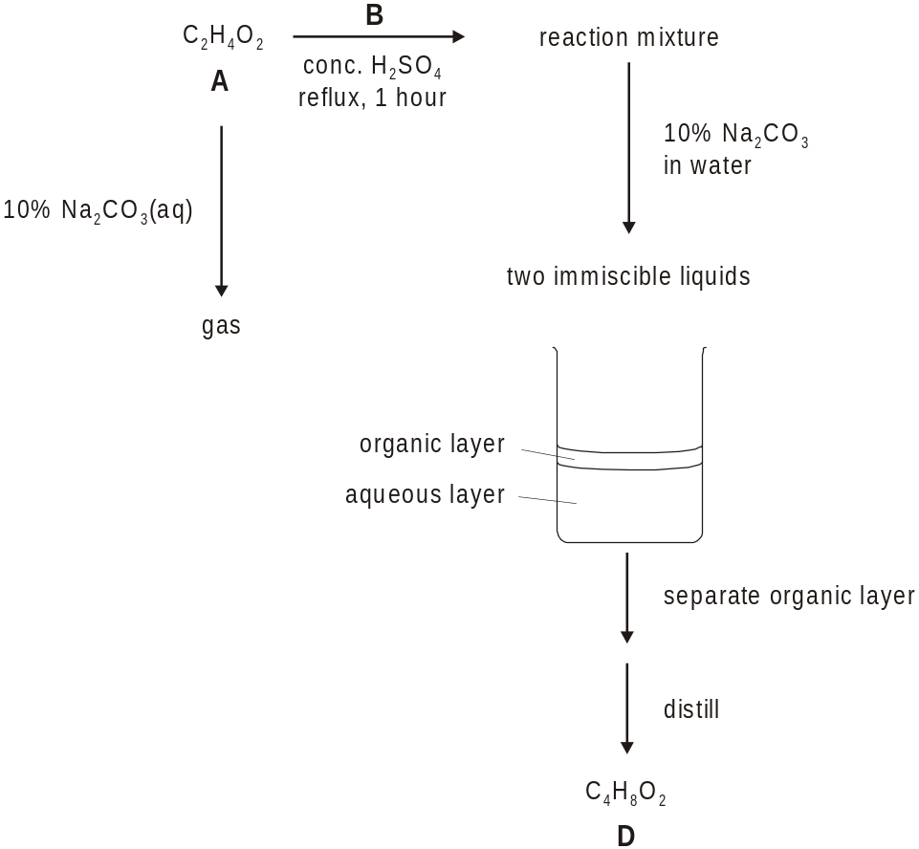

Question 25 continues on page 19

 |  | Marks
Question 25 (continued)
 | Draw and label a diagram of the apparatus used to heat the reaction mixture under reflux. | 3
 | Explain why reflux is used in this reaction. | 2
………………………………………………………………………………...
……………………………………………….………………………………..
………………………………………………………………………………...
……………………………………………….………………………………..

 | The yield of D was found to be 50%. Explain this result. | 1
………………………………………………………………………………...
……………………………………………….………………………………..

Question 25 continues on page 20

 |  | Marks
Question 25 (continued)
 | Calculate the volume (at 25°C and 100 kPa) of CO₂(g) produced when 2.54 g of A reacts completely with excess Na₂CO₃(aq). | 3
………………………………………………………………………………...
……………………………………………….………………………………..
………………………………………………………………………………...
……………………………………………….………………………………..
………………………………………………………………………………...
……………………………………………….………………………………..

 |  | Marks
Question 26 (5 marks)
Oxygen and its allotrope, ozone are both found in the Earth’s atmosphere.
 | Compare the structure and bonding of these two allotropes and use diagrams to illustrate your answer. | 3
………………………………………………………………………………...
……………………………………………….………………………………..
………………………………………………………………………………...
……………………………………………….………………………………..
………………………………………………………………………………...
……………………………………………….………………………………..
 | Explain how ozone occurs in the stratosphere. | 1
………………………………………………………………………………...
……………………………………………….………………………………..
………………………………………………………………………………...
……………………………………………….………………………………..
 | A high altitude balloon measured the concentration of ozone as 1.23 mL per 100 litres of air.  Express this concentration of ozone in ppm. | 1
………………………………………………………………………………...
……………………………………………….………………………………..
………………………………………………………………………………...
……………………………………………….………………………………..

 |  | Marks
Question 27 (5 marks)
25.00 mL of 0.025 M silver nitrate solution was titrated with sodium chloride solution of unknown concentration. A conductivity probe connected to a data logger was used to monitor the reaction. The results are shown below.

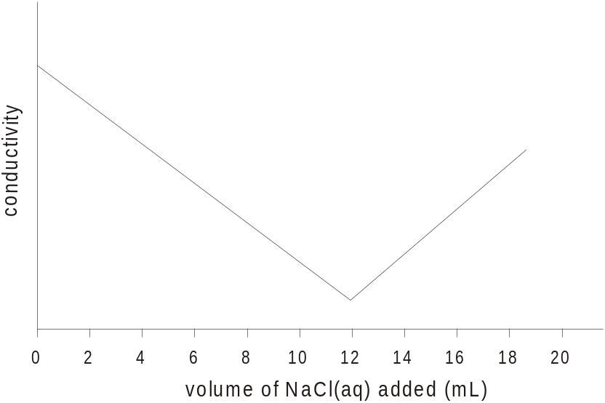

 | Write a balanced chemical equation for the reaction taking place. | 1
 | ………………………………………………………………………………...
 | What volume of sodium chloride solution was required for complete reaction? | 1
 | ………………………………………………………………………………...

Question 27 continues on page 23

 |  | Marks
Question 27 (continued)
 | Calculate the concentration of the NaCl(aq). | 2
………………………………………………………………………………...
……………………………………………….………………………………..
………………………………………………………………………………...
………………………………………………………………………………...

 | Why does the conductivity not drop to zero? | 1
………………………………………………………………………………...
……………………………………………….……………………………….

 | Marks
Question 28 (7 marks)
Assess the impact of advances in polymerisation reactions on society and the environment. | 7
……………………………………………………………………………….…………
……………………………………………………………………………….…………
……………………………………………………………………………….…………
……………………………………………………………………………….…………
……………………………………………………………………………….…………
……………………………………………………………………………….…………
……………………………………………………………………………….…………
……………………………………………………………………………….…………
……………………………………………………………………………….…………
……………………………………………………………………………….…………
……………………………………………………………………………….…………
……………………………………………………………………………….…………
……………………………………………………………………………….…………
……………………………………………………………………………….…………
……………………………………………………………………………….…………
……………………………………………………………………………….…………
……………………………………………………………………………….…………
……………………………………………………………………………….…………
……………………………………………………………………………….…………
……………………………………………………………………………….…………

Section II

Total marks (25)
Attempt ONE question from Questions 29 - 32
Allow about 45 minutes for this Section

Answer the question in a writing booklet. Extra writing booklets are available.
Show all relevant working in questions involving calculations.

 | Pages
Question 29 | Industrial Chemistry ………………………………………. 27
Question 30 | Shipwrecks and Salvage
Question 31 | Biochemistry of Movement
Question 32 | Chemistry of Art …..………………………….…..……. 28-29

BLANK PAGE

 |  |  | Marks
Question 29 - Industrial Chemistry (25 marks)
 | An important role of the chemical industry is to provide alternatives to natural products.
 | (i) | State one dwindling natural resource which is not a fossil fuel. | 1
 | (ii) | Outline two uses of the natural product identified in (i) and name a replacement material used instead. | 3
 | The following equation represents the decomposition of hydrogen iodide.  2HI(g) H₂(g) + I₂(g)  0.002 mol of hydrogen iodide was heated at 764 K in a 1000 cm³ bulb. When an equilibrium was established the amount of iodine present was determined. 0.00028 moles of iodine were present.  Calculate K for the reaction at 764 K. |  | 4
 | Sulfuric acid is an important industrial chemical.
 | (i) | Outline one industrial use of sulphuric acid, illustrating your answer with a chemical equation. | 2
 | (ii) | Describe the process used to extract sulfur from mineral deposits, and identify a property of sulfur which allows this. | 3
 | (i) | Outline and explain the safe dilution of concentrated sulphuric acid. | 2
 | (ii) | Describe an experiment you have done to investigate the reaction of sulphuric acid as a dehydrating or oxidising agent. | 4
 | Discuss the following statement.  The conversion of molten sulphuric acid (the Contact Process) is a multi-step process. The conditions used for the conversion of SO₂ to SO₃ are a compromise between reaction rate and equilibrium yield. |  | 6
 | End of Question 29

 |  |  | Marks
Question 32 - Chemistry of Art (25 marks)
 | (i) | Name and give the chemical composition and colour of a pigment used by Australian Aboriginal people. | 1
 | (ii) | Illustrate the relationship between the discovery of new mineral deposits and an increase in the range of available pigments by describing an historical example. | 3
 | Discuss the use of two pigments by early Egyptian or Roman people. |  | 4
Na⁺, K⁺, Ca²⁺, Ba²⁺, Sr²⁺ and Cu²⁺ can be identified by their flame colour.
A colourless solution contained two of the above ions. When a solution of potassium carbonate was added to the unknown solution a dense white precipitation formed. When precipitation was complete, the solid was filtered off and washed.
The filtrate gave a yellow flame colour.
The solid residue was ‘dissolved’ in hydrochloric acid and the solution flame tested – giving a green colour.
 | (i) | What cations were present in the original solution? | 2
 | (ii) | Describe how a flame test is carried out. | 3

Question 32 continues on page 29

 |  |  | Marks
Question 32 (continued)
(d) | (i) | Explain how the Pauli exclusion principle and Hund’s rule can be used to predict the arrangement of electrons in atoms. | 2
 | (ii) | Use the information in the diagrams below to describe the development of the Bohr model of the atom from the hydrogen spectrum. | 4

The visible emission spectrum of H
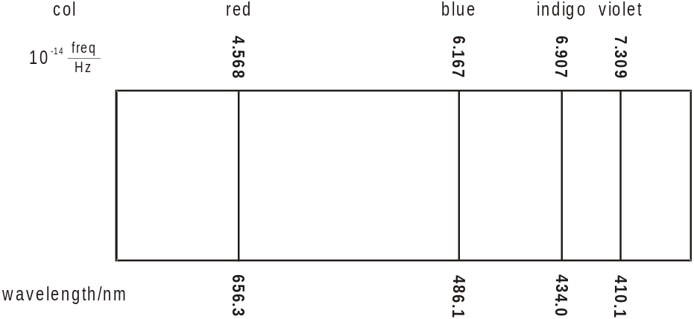

Energy level diagram for the H atom
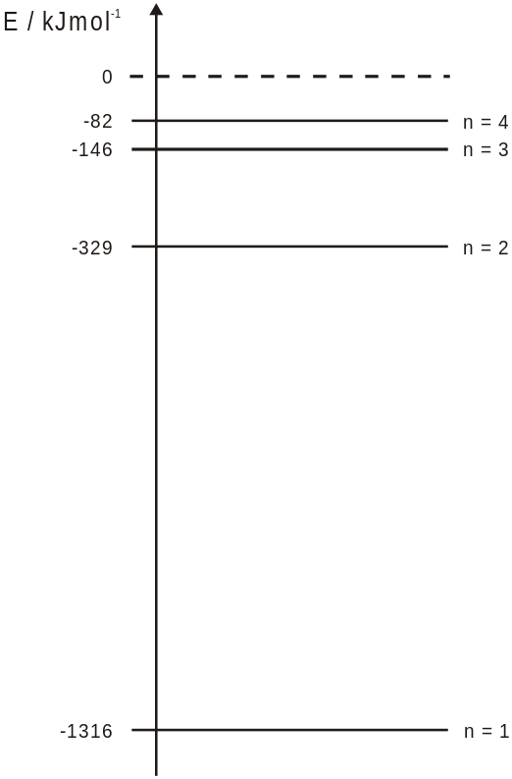
(e) | Describe the use of laser microspectral analysis in art. |  | 6
 | End of Question 32

BLANK PAGE

Chemistry

Data Sheet

Avogadro’s constant, N_{A} ………………………………………………. 6.022 x10²³ mol^{–1}
Volume of 1 mole ideal gas: at 100 kPa and
at 0 °C (273 K) ………………………… 22.71L
at 25 °C (298K) ………………………… 24.79 L
Ionisation constant for water at 25°C (298.15 K), K_{w} …………………. 1.0 × 10⁻¹⁴
Specific heat capacity of water ………………………………………….. 4.18 × 10³ Jkg^{–1}K^{–1}

Some useful formulae
pH = – log₁₀[H⁺] ΔH = – mCΔT

Standard Potentials

K⁺ + e– |  |  | K_{(s)} | –2.94 V
Ba²⁺ + 2e– |  |  | Ba_{(s)} | –2.91 V
Ca²⁺ + 2e– |  |  | Ca_{(s)} | –2.87 V
Na⁺ + e– |  |  | Na_{(s)} | –2.71 V
Mg²⁺ + 2e– |  |  | Mg_{(s)} | –2.36 V
Al³⁺ + 3e– |  |  | Al_{(s)} | –1.68 V
Mn²⁺ + 2e– |  |  | Mn_{(s)} | –1.18 V
H₂O + e– |  |  | ½ H_{2(g)} + OH– | –0.83 V
Zn²⁺ + 2e– |  |  | Zn_{(s)} | –0.76 V
Fe²⁺ + 2e– |  |  | Fe_{(s)} | –0.44 V
Ni²⁺ + 2e– |  |  | Ni_{(s)} | –0.24 V
Sn²⁺ + 2e– |  |  | Sn_{(s)} | –0.14 V
Pb²⁺ + 2e– |  |  | Pb_{(s)} | –0.13 V
H⁺ + e– |  |  | ½ H_{2(g)} | 0.00 V
SO₄^{2–} + 4H⁺ + 2e– |  |  | SO_{2(g)} + 2H₂O | 0.16 V
Cu²⁺ + 2e– |  |  | Cu_{(s)} | 0.34 V
½ O_{2(g)} + H₂O + 2e– |  |  | 2OH– | 0.40 V
Cu⁺ + e– |  |  | Cu_{(s)} | 0.52 V
½ I_{2(s)} + e– |  |  | I– | 0.54 V
½ I_{2(aq)} + e– |  |  | I– | 0.62 V
Fe³⁺ + e– |  |  | Fe²⁺ | 0.77 V
Ag⁺ + e– |  |  | Ag_{(s)} | 0.80 V
½ Br_{2(l)} + e– |  |  | Br– | 1.08 V
½ Br_{2(aq)} + e– |  |  | Br– | 1.10 V
½ O₂ + 2H⁺ + 2e– |  |  | H₂O | 1.23 V
½ Cr₂O₇^{2–} + 7H⁺ + 3e– |  |  | Cr³⁺ + H₂O | 1.36 V
½ Cl_{2(g)} + e– |  |  | Cl– | 1.36 V
½ Cl_{2(aq)} + e– |  |  | Cl– | 1.40 V
MnO₄– + 8H⁺ + 5e– |  |  | Mn²⁺ + 4H₂O | 1.51 V
½ F_{2(g)} + e– |  |  | F– | 2.89 V

